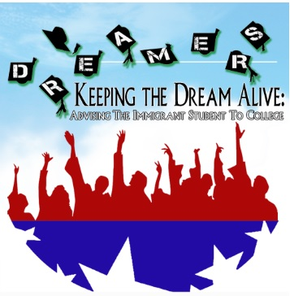
Colorado DREAMer Ally Network

Recommendations & Resources
for Informing & Supporting DREAMers

Information for DREAMers & Their Families

DACA or Deferred Action for Childhood Arrivals
- If you are new to DACA, DO NOT APPLY!
- If you are renewing DACA, move forward with caution.
- If you were planning to travel with your DACA via Advanced Parole, go but come back before Jan. 20, 2017
This information comes from National Immigration Law Center and United We Dream.

ASSET
CO ASSET (SB13-033) is state law that has not changed and will not change in the near future. ASSET is in state tuition for eligible Colorado residents. Go here for more details: www.ciccoloradoasset.org

To find out if you qualify, click here: https://www.ccd.edu/administration/non-academic-departments/asset-daca/what-colorado-asset-bill

College Opportunity Fund
COF Funds are a part of the CO ASSET law and are available to ASSET students.

FAFSA
If you are DACA or undocumented, ask the financial aid office of the college/university you plan to attend if they have an alternative financial aid form you can use instead of the FAFSA. Consider using a P.O. Box for your mailing address.

K-12 Resources
Denver Public Schools put out letters and statements informing families and students of their rights under the law and ensuring school safety for all students. Please consider having your school/district do something like this.

https://www.dpsk12.org/responding-to-immigration-concerns/

https://www.dpsk12.org/dps-board-reinforces-schools-safe-for-all-students/

For Teachers Hoping to Hold Supportive Discussions
http://tinyurl.com/k12electionresources or http://goo.gl/jxCiNz

For Students
http://aclu-co.org/know-your-rights/#
This website has a great section on Students’ Rights at Public Schools including information about your rights to protest and a section on discrimination on the basis of sexual orientation in public businesses.

DACA Action and Support Groups in Colorado
Caminando Unidos (DACA students at UNC)
CCD Dreamers United- Find on Facebook
Dreamers United @ Colorado State University- Find on Facebook
CU Dreamers- Find on Facebook or contact Reydesel.salvidrezrodriguez@ucdenver.edu
UndoCommittee & Auraria Dreamers (Closed Group but contact Reydesel for info)

Other things you can do
Stay up to date with the news but use reputable news sources and verify that what you see is accurate. At the end of this document is a list of websites that are reputable.

Get involved locally. Get involved nationally.
Consider your local organizations or the national Movimiento Cosecha/Harvest Movement at https://cosecha.dev.glocal.coop/

Know Your Rights
You can search for a Know Your Rights workshop or event so that you can be informed on what your rights are if you are stopped, harassed or confronted.

Upcoming Events:
Legal Advice for Dreamers #HereToStay
Saturday Dec 3, 9:30 am at St. Cajetan’s on the Auraria Campus

Know Your Rights/Conozca Sus Derechos
New America School at 5806 W. Alameda Ave, Denver, CO 80226
Saturday Dec 3, 10 am to Noon

If you face discrimination, intimidation or harassment, contact:
U.S. Department of Justice, file a complaint with the Civil Rights Division
https://www.justice.gov/actioncenter/submit-complaint
Education 877-292-3804 or 202 514-4092
Employment 800-669-4000 (voice)

Useful Websites:
My Undocumented Life
https://mydocumentedlife.org/2016/11/13/post-election-recommendations-for-school-administrators-educators-counselors-and-undocumented-students/

Immigrant Legal Resource Center
https://www.ilrc.org/immigrant-youth

Educators 4 Fair Consideration
http://e4fc.bmeurl.co/6984436

United We Dream
http://unitedwedream.org/

National Immigration Law Center
https://www.nilc.org/

Colorado Immigrant Rights Coalition
http://coloradoimmigrant.org/

Legal Resources in Colorado, including lists of immigration attorneys:
http://www.ciccoloradoasset.org/item/254-legal-resources

