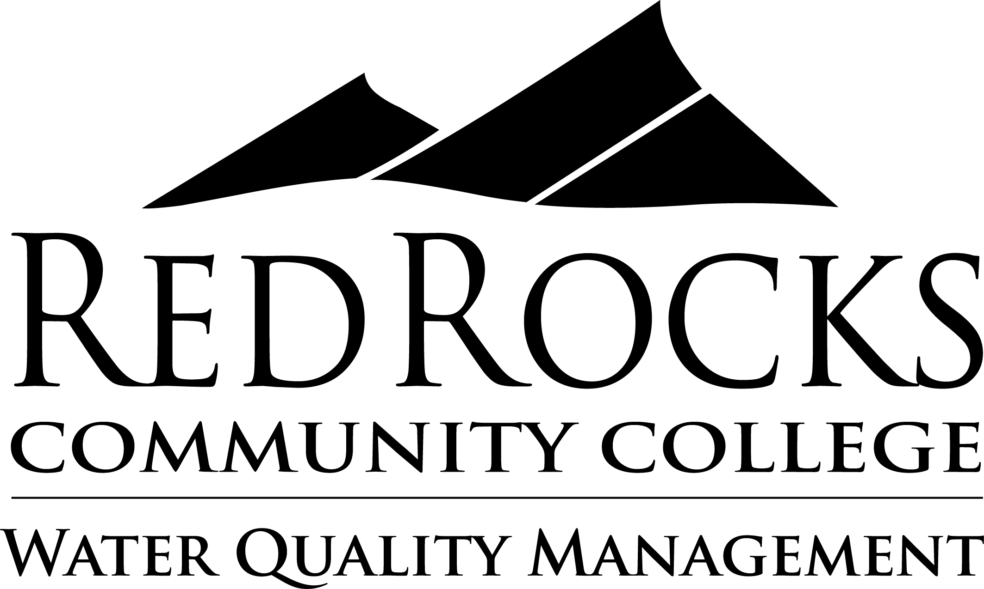
Water Quality Management Technology Student Competencies

The Water Quality Management Technology Department at Red Rocks Community College is committed to educating students about the water and wastewater industry. This comprehensive training program is designed to prepare students with hands-on experiences and challenges that make them job ready. These student competencies dictate the practical, theoretical, and applicable skills taught within the program and needed for successful job performance.

Knowledge Competencies: Knowledge competencies explain what a student should understand after completing the Water Quality Management Technology program.

- Describe mathematical formulas and scientific concepts utilized by professionals working in the water and wastewater industry.
- Explain state and federal regulations applied to the water and wastewater industry.
- Identify best practices that promote safety within the workplace.
- Read and interpret design basics in the water and wastewater industry.
- Possess a basic understanding of the structure, purpose, products/services, and priorities within the water and wastewater industry.
- Express an interest in ongoing learning, professional judgment, and workplace ethics.

Skills Competencies: Skills competencies explain what a student should be able to demonstrate after completing the Water Quality Management Technology program.

- Communicate effectively through a variety of writing and presentation styles.
- Demonstrate a positive attitude when learning new concepts, working with employees, and responding to criticisms.
- Apply mathematical, scientific, and technical skills to real-world situations.
- Interpret troubleshooting needs and respond appropriately.
- Practice all job duties with the recognition, avoidance, and protection of all safety and health hazards.

