Events |  | - October 6, 2015  - Updated
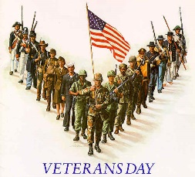 |  | Education Benefits 101  October 14th 12:00pm Understanding options and limitations of benefits, so you can better plan your academic career  Transfer TO a 4 Year College  November 10th 12:00pm Choosing the right Program/School for you. Application Success tips.  Veterans Day Celebration  November 11th Veterans day ceremony and speakers 11:00am, veteran film screening, Community mixer, Obstacle Course  Manage Stress  November 17th 12:00pmDiscuss the effects of stress, resources available and techniques for managing it  [Menu Item Name]  [Menu item description.]

