Event/Appointment Accessibility Statement

Please include the following statement on any marketing for events or on appointment forms:

## **Print:**

**Need access?** Submit an Event/Appointment Accommodation Request Form or contact Accessibility Services at 303-914-6733 or [access@rrcc.edu](mailto:access@rrcc.edu) at least one week in advance, or as soon as possible, to request disability-related accommodations.

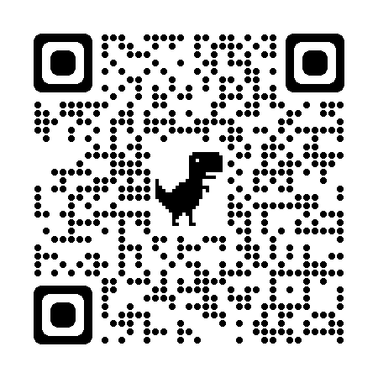

## **Digital:**

**Need access?** Submit an [**Event/Appointment Accommodation Request Form**](https://nam12.safelinks.protection.outlook.com/?url=https%3A%2F%2Frrcc.formstack.com%2Fforms%2Fevent_appt_access&data=05%7C02%7CChristina.Reyes%40rrcc.edu%7C400f2d7661004caec67f08dda77bde6b%7C2a22b1ea780a4a3db1b7ce5f9ac45368%7C0%7C0%7C638850872712138644%7CUnknown%7CTWFpbGZsb3d8eyJFbXB0eU1hcGkiOnRydWUsIlYiOiIwLjAuMDAwMCIsIlAiOiJXaW4zMiIsIkFOIjoiTWFpbCIsIldUIjoyfQ%3D%3D%7C0%7C%7C%7C&sdata=aUff5KzA3tqB99gY88yj21sQfUtzDu4fHraqZvMf%2FZ0%3D&reserved=0) or contact Accessibility Services at 303-914-6733 or [access@rrcc.edu](mailto:access@rrcc.edu) at least one week in advance, or as soon as possible, to request disability-related accommodations.

## Rationale:

*In order to ensure inclusion and accessibility of all campus events, meetings, activities and appointments, including on campus, remote and online, we request that the accessibility statement is included on all promotional material, emails, flyers and appointment/RSVP platforms.*

*The statement informs participants, including students, faculty, staff and guests, of how to request accommodations such as wheelchair accessibility, American Sign Language interpretation, real-time transcription and closed captioning. Accessibility Services will work with the sponsoring department to provide the requested accommodations****.*** *One-week advance notice is requested, however, a good faith effort will be made up until the time of the event to provide accommodations.*