Getting Started with TutorMe: A Student Guide

TutorMe Overview
RRCC offers 24/7 online tutoring, through TutorMe. Students can work with a live tutor and receive help with homework assignments and other coursework, in a variety of academic subjects. This service allows students to meet with a qualified tutor using audio/video conferencing, text chat, screen sharing, document upload, and a shared whiteboard space. Students can also review recordings of their sessions, afterwards, in order to assist with their learning process.

Directions to Access TutorMe from D2L
- Make sure you are logged into D2L
- Click on the Online Tutoring Link in the D2L Navigation
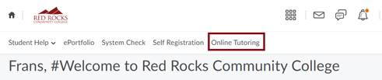
- On the TutorMe page, click the Connect with a Tutor button.
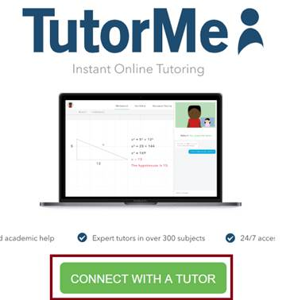
- Then type the subject you need help with in the search bar.
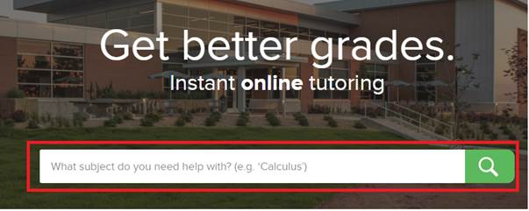
- A window will pop up allowing you to describe your problem and to upload a file if needed. Finally, submit your issue to be matched with a TutorMe tutor.
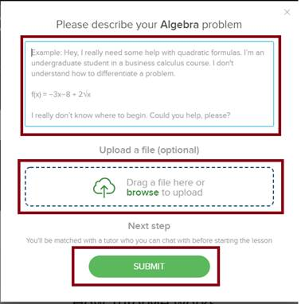

Tutoring Subjects Available
- Accounting
- Biology
- Chemistry (Regular and Organic )
- Computer Information System (Microsoft Office and Programming)
- Computer & Networking Tech (Computer Networking)
- Communication
- Computer Programming (Python, C++, etc.)
- Computer Web-Based
- Economics
- English as a Second Language
- Geology
- Japanese
- Math
- Multimedia Graphic Design (Photoshop, etc.0
- Physics
- Plumbing
- Psychology
- Spanish
- Water Quality Management

