Fall 2020 6.26.20 All-Student Email:
Dear Valued Student,
Thank you for your patience and flexibility as we have prepared a Fall 2020 semester schedule that will ensure safety for all. In the spring, we all had to adjust swiftly to online course delivery. For fall, we’ve been able to plan ahead to produce the best outcomes for students, staff, and faculty.
We are happy to announce that the changes to our Fall schedule are complete and REGISTRATION FOR ALL CLASSES IS NOW OPEN! Please see the chart below for more information on the class formats, delivery modes, locations, and costs.
Class Format: | Class Delivery: | Location (how to access course): | Cost:
Remote | Online with a schedule. No on-campus presence. Instructors and students log-in on specific days and times for class | In the Location column, you’ll see “RDL REMOTE” | On-campus tuition rate
Hybrid | Some on-campus presence and some online presence | In the Location columns, you’ll see “RDL REMOTE WITH” followed by specific days, class time, date range, and classroom number if meeting on campus.  If class meets virtually, only a day and time is listed | On-campus tuition rate
Online | No on-campus presence or need to be available on a specific day or time for class | In the Location column you’ll see either “RDL RRCCONLINE” or “CCCONLINE” | Online tuition rate

When we made the decision to convert all on-campus classes for the Fall to remote, hybrid, or online class formats, we knew it would be a challenge. Although the past couple of weeks may have caused confusion and even frustration, your safety and success remain our top priorities. We believe the range of options we devised will help you coordinate your education goals with others parts of your life, such as work schedules, childcare, and family life.
For more information about our Fall classes, visit: rrcc.edu/fall-classes-information. For assistance from one of our student success departments, please call 303-914-6600 or email jen.broadwater@rrcc.edu. As always, the entire Red Rocks community remains committed to helping you achieve your career and educational goals!
Sincerely,
Jen Broadwater
Registrar, Student Success
jen.broadwater@rrcc.edu

Kate Haddon
Manager, Instructional Support
kate.haddon@rrcc.edu

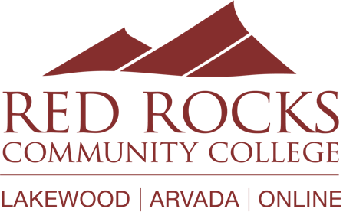

One thing is certain – life has changed but your educational goals do not have to.

