G.R.E.A.T. Note Taking

G.R.E.A.T. Note Taking Tips =

Get ready
wRite
Edit
Ask questions
Test yourself

Get Ready Phase: Set the stage
- Complete all written homework assignments
- Complete all reading homework assignments
- Bring the right materials
- Browse notes prior to class, anticipate a “pop” quiz
- Find a seat that allows you to spread out if possible
- Prepare yourself to be focused

wRite Phase: Note taking
- Include key information, ex. main ideas, facts, details, examples & definitions
- Listen for instructor’s cues of importance, ex. repetition, enthusiasm
- Use abbreviations and symbols
- Write only on the front side of the paper (or leave room between concepts)
- Try the Cornell, outline, and/or mind map formats (see examples)

Edit Phase: Make notes useable
- Clean up after class, ex. check spelling
- Fill in the gaps
- Maximize your chosen note taking strategies
- Use the back side of the paper (or the gaps you left) for the following:
  - Vocabulary words
  - Make up your own examples
  - Draw charts, pictures, diagrams
  - Add new notes from your textbook
  - Write down questions for your instructor

Ask Questions Phase: Put yourself in an instructor role
- Design sample test questions (try turning headings into questions)
- Change passive learning to active learning

Test Yourself Phase: Move info to long term memory
- This occurs after your sample test questions are created
- Read the questions and recite your answers aloud or write them out

Cornell Method Example:

Cue Column – 1/3 portion of the page | Today’s Date, Instructor Name, Class, Topic(s), Your Name
Main ideas here –Insert after lecture | All notes go here during class lecture – 2/3 portion of the page
Summary section – Create sample test questions here

Outline Example:
- First main topic
  - Subtopic
    - Detail
    - Detail
  - Subtopic
    - Detail
    - Detail
- Second main topic
  - Subtopic
    - Detail
    - Detail
  - Subtopic
    - Detail
    - Detail

Mind Map Example:

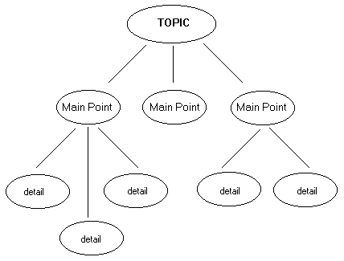

Miscellaneous Tips:

- Use a three-ring binder so you can add (and move around) items with ease
- Create flash cards from 3x5 note cards
- Label the top of your notes with the date and topic
- Copy down instructor info – verbal, ppt, whiteboard, etc.
- Print out powerpoint slides (3-4 per page) if provided on D2L
- Leave blank spaces for added extras later
- Use graphics for parts of your notes that you need to focus on (ex.?)
- Use graphics for parts of your notes that you totally know (ex. )
- Use a recording device like a “smart pen” – this is cool writing/recording technology! (Don’t forget you must get your instructors’ permission first)
- Try highlighting, but use sparingly (<10%)
- Computer generate your notes and/or create summary pages
- Notice your wandering mind, it’s ok, just refocus
- Participate in class discussions
- Relate the class and your notes to your ultimate goals
- “Be” with the instructor with eye contact, good posture, front row, etc.
- Sit in a class room location with minimal distractions
- Compare notes with a classmate, if possible, right after class
- Experiment with formats and use what works for you
- Ask Your Instructor for Clarification
------------------------------------------------------------------------------------------------------

Adjusting to Different Lecture Styles:

“Talking over your Head” – When difficult concepts are not thoroughly explained.
- Strategy: Ask questions (lots if necessary!)

“Rambling” – When the presentation consistently goes off track from the topic at hand.
- Strategy: Ask carefully worded questions related to the last main point.

“Mumbling” – When the instructor speaks too softly or does not enunciate well.
- Strategy: Sit up front, listen closely, and ask to repeat main points.

“Tortoise and Hare” – When the instructor speaks too slowly or too quickly.
- Strategy (tortoise): Ask to repeat or clarify the main points.
- Strategy (hare): Anticipate what is to come, abbreviate, and make connections between concepts. Try not to stress out and fill in the gaps later!

** Comparing notes with a classmate AND communicating with your instructor are two good strategies for all of the above!

Dana Kobold | dana.kobold@rrcc.edu | 303.914.6176 | rrcc.edu/first-year-experience
Handout info researched and created by Dana Kobold, FYE Coordinator (Revised SP 19)
Content adapted from Study Skills for Learning Power (by Hellyer, Robinson, Sherwood) and the Wallace State Community College - Hanceville website

