High School vs College

Mindsets for College Success
As you can imagine, high schools and colleges vary significantly across the country. Thus, educational experiences can differ significantly from school to school and from student to student.
As a result, keep that in mind as you gather opinions from others about your transition to college.

Below is a comparison chart that illustrates GENERAL differences between high school and college. Remember, YOU will need to form your own opinions and plan/adjust accordingly.

High School | College
Classes:  - Classes are arranged for you  - Classes meet daily  - Teachers monitor attendance  - Classes average less than 30 students  - You are given text books at little or no cost  - Courses to meet graduation requirements are relatively consistent | Classes:  - You arrange your classes  - Classes may meet just once a week  - Professors may not monitor attendance  - Classes may number 100 students or more  - You need to budget money for text books  - Courses to meet graduation requirements differ according to the program you study
Instructors:  - Have training in teaching methods courses  - Provide information for your notes  - Remind you of assignments and due dates  - Provide you with the information you missed when you were absent  - Present material to help you understand the concepts in the text book  - Guide you through thought processes  - Approach you if they believe you need help  - Are available for conversation and assistance before, during, and/or after school | Instructors:  - Have training in their area of expertise  - Expect you to identify key points for your notes  - Provide you with a syllabus so you can track assignments and due dates  - Count on you to get content for missed classes  - Encourage you to relate the material presented in class with the concepts in the text book  - Push you to think critically for yourself  - You initiate contact if you need help  - Are available for conversation and assistance during their specified office hours
Studying:  - The amount of time studying is comparable to the time spent in class  - Teachers allot class time for homework  - Your studying involves mainly material in your text book | Studying:  - You should study at least 2 hours outside of class for each hour in class (ex. 3-credit hour class = 6 hours of review out of class)  - Math and Science require greater study time  - Little (or no) class time is allotted for homework  - Your studying involves reading and writing assignments that are not in your text book
Tests:  - Testing is frequent and covers small amounts of material  - Quizzes occur between tests  - Makeup tests are an option  - Teachers (re)schedule test dates to avoid conflicts with other school activities  - Teachers conduct review sessions prior to the day of the test  - Mastery is often seen as the ability to recognize the same information presented in class | Tests:  - Testing is infrequent and covers large amounts of material  - Courses may have just two or three tests total  - Makeup tests may not be an option  - Professors schedule test dates at the beginning of the course, regardless of school activities  - Professors encourage students to form study sessions prior to the day of the test  - Mastery is often seen as the ability to apply and problem solve what you have learned to new situations

Grades:  - Grades are given for homework  - Consistently good homework grades help raise your overall grade when test grades are low  - Extra credit projects are offered to help you raise your grade  - Final class grades are determined by a “good faith effort” – if you try hard, you may pass  - Final class grades of a D or higher are required to graduate with a diploma | Grades:  - Grades may not be given for homework  - Grades on tests and papers provide most of the overall course grade  - Extra credit projects may not be offered to help you raise your grade  - A good effort is important, but likely won’t change your status from failing to passing  - Final class grades of a C or higher are usually required to graduate with a certificate or degree
Personal Freedoms:  - You are told your responsibilities and are “called out” if your behavior is out of line  - Your time is guided by others  - Your parents are involved in your high school experience  - Info about your high school success (or failure) is readily shared between the school and your parents  - The high school is obligated to teach you – mandatory enrollment/attendance until a certain age is reached | Personal Freedoms:  - You are responsible for your actions and their consequences  - You manage your own time  - Your parents are as involved in your college experience as you choose them to be  - Info about your college success (or failure) cannot be shared between the college and your parents (FERPA)*  - The college is not obligated to teach you – voluntary enrollment/ attendance on your part  *Note: There is paper work to have communication
Miscellaneous Ideas: | Miscellaneous Ideas:

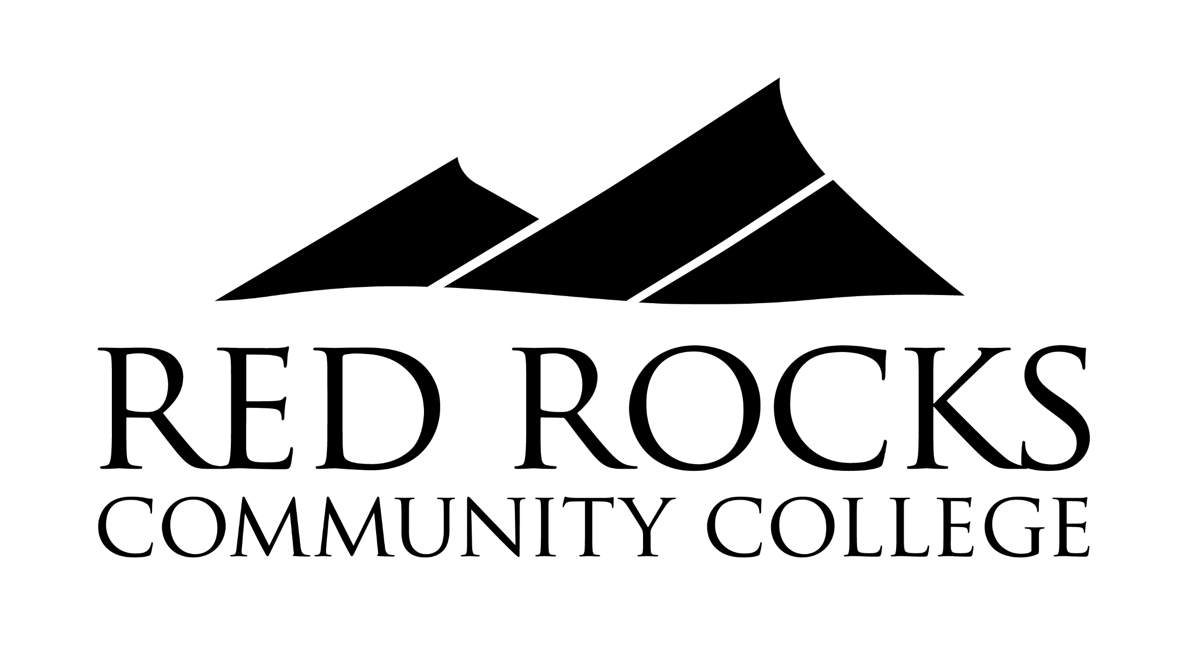
Dana Kobold | dana.kobold@rrcc.edu | 303.914.6176 | rrcc.edu/fye
Handout info researched and created by Dana Kobold, FYE Coordinator (Revised SP 21)
Content adapted from the Adelphi University website

