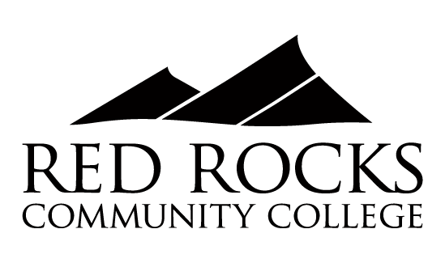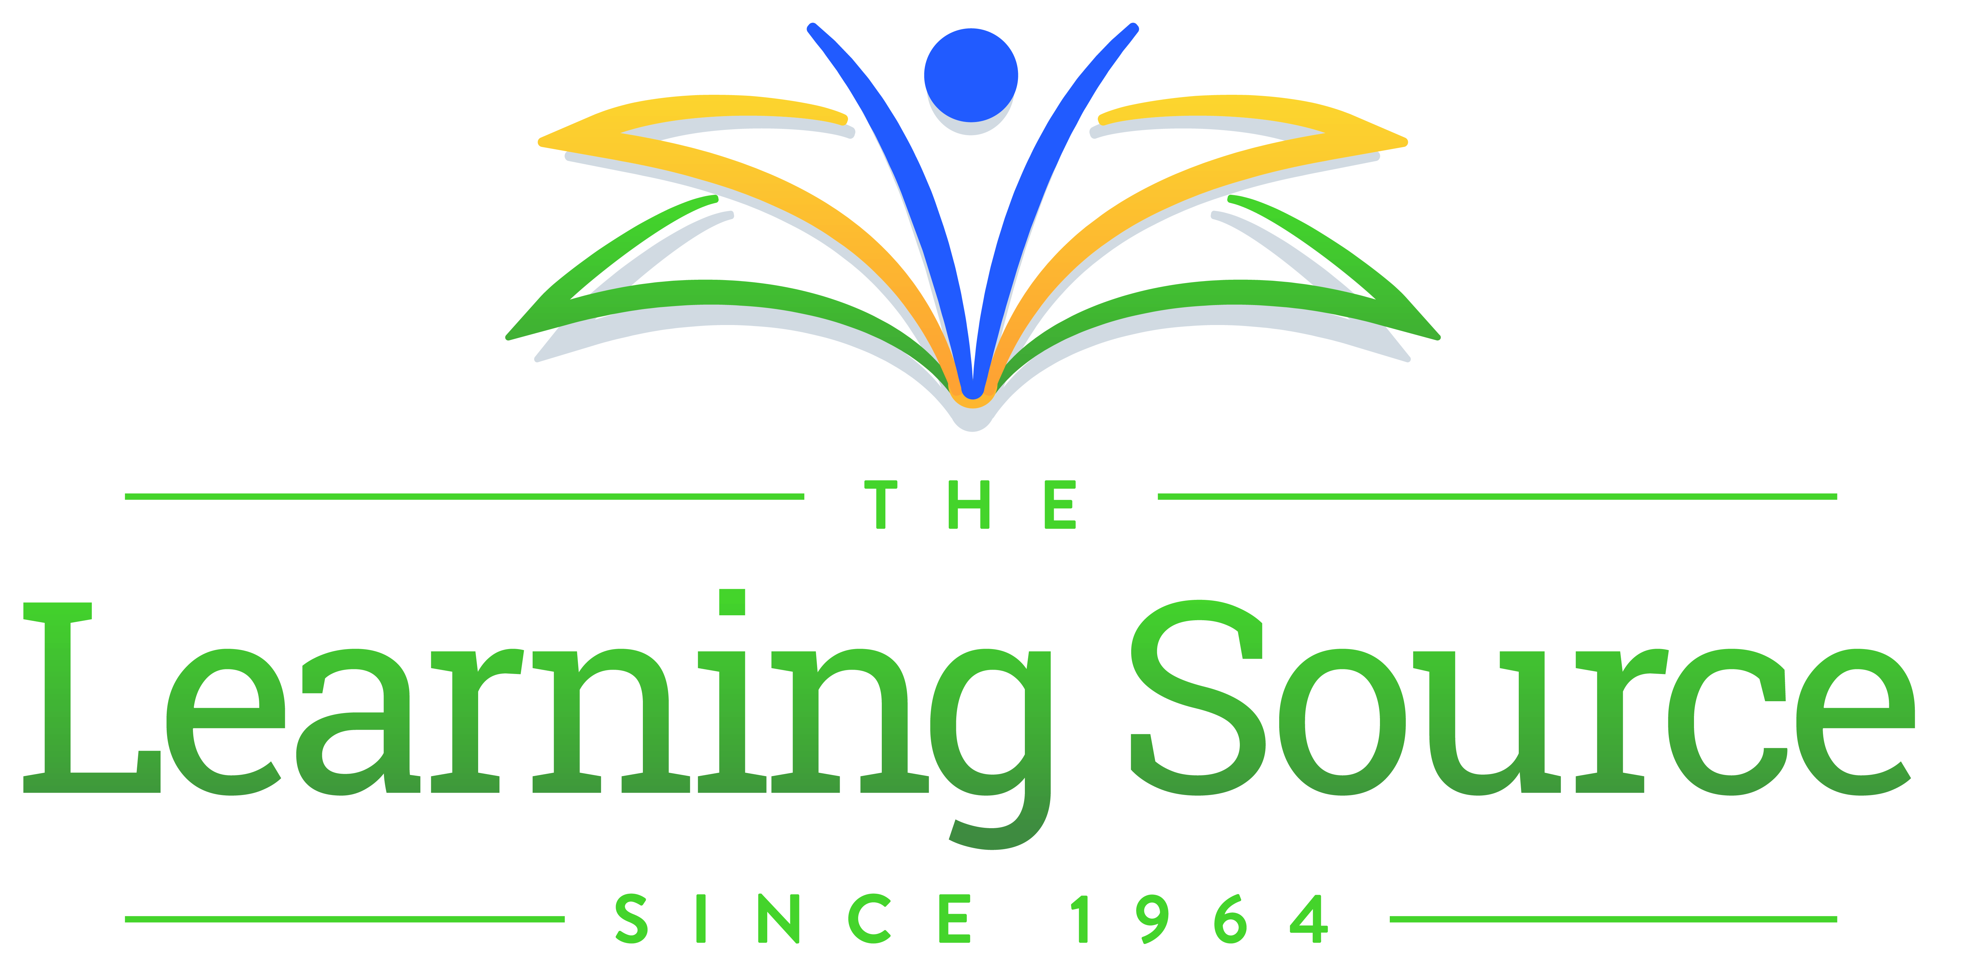

THE LEARNING COLLABORATIVE

Do you need additional skills in math or English to enter a college level course? The Learning Collaborative at Red Rocks can help!

Enroll or Co-enroll in our FREE non-credit course to receive at least 80 hours of instruction and tutoring to improve your math or English skills. Successful completion prepares you to succeed in courses such as MAT-0250, MAT-0300, MAT-1140, ENG-0092, or ENG-0094.
Learning Collaborative courses are completely FREE to all participants.
Summer/Fall 2022 COURSE SCHEDULE:
CRN | Course | Start Date | End Date | Days | Time | Location
4035  5002 | Math 1001-040  Math 1001-040 | 7/6/22  9/7/22 | 8/18/22  12/15/22 | M/W/TH  M/W/TH | 6 pm -9 pm  6 pm -9 pm | REA 1415 hybrid course*
5001 | Math 1001-001 | 9/7/22 | 12/15/22 | T/W/TH | 9 am - 12 am | REA 1415
5065 | PERS 1001-001  English | 9/7/22 | 12/15/22 | T/W/TH | 1 pm – 4 pm | REA 1415

Complete the online Formstack form [www.rrcc.edu/the-learning-collaborative] to pre-register for a Learning Collaborative course. You will be contacted about how to enroll.
*Class will meet remotely (ZOOM) on Monday and Wednesday evenings and face-to-face on Thursday evenings.
Register Now for Summer & Fall Semesters 2022
For more information contact Tamara Stubbs at tamara.stubbs@rrcc.edu or jeralyn.braddock@rrcc.edu or call 303-914-6571

The Learning Collaborative is a partnership between Red Rocks Community College and The Learning Source to serve adults in our community from basic adult education to college access.

