Class Rosters in Banner

Banner Desktop Shortcut
Step 1. Launch your Internet Browser
Step 2. Go to URL: http://www.cccs.edu/BannerSelfService/student/banner.html
Step 3. Click on File and select Send
Step 4. Click on “shortcut to desktop”

Class Rosters
Step 1. Click on the desktop shortcut to Banner
Step 2. Under “Self Service Banner – Production Environments (PROD), click Red Rocks Community College
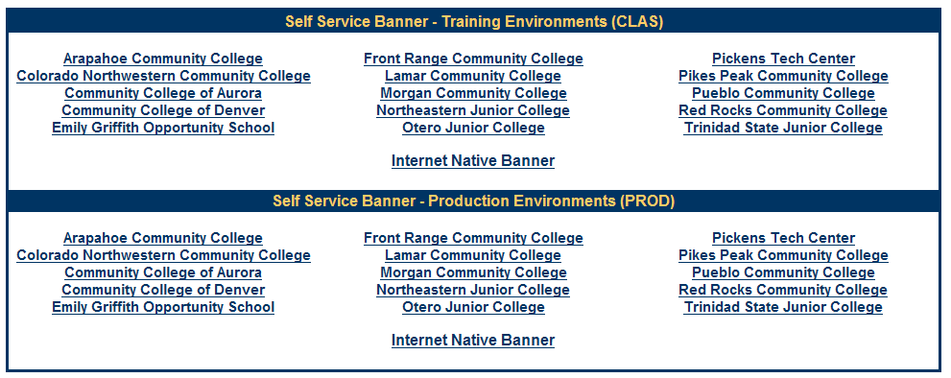
Step 3. Click Login link on the left side of your screen.
Step 4. User ID: S# (Must be a capital S)
Step 5. PIN: birthday MMDDYY
Step 6. Click on Faculty & Advisor Services
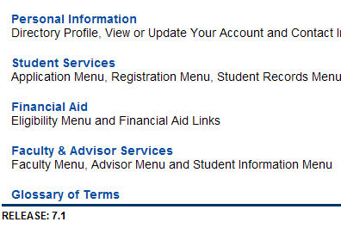
Step 7. Click Faculty Menu
Step 8. Click Faculty Detail Schedule
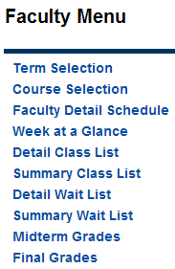
Step 9. Select the current term and click Submit
Step 10. For a roster, click Class List
