Monday – Friday  7:00 am – 10:00 pm  Saturday:  7:00 am – 5:00 pm  Sunday: Closed | Schedule closures or changes for the following dates:  April 21st – Both Campuses Closed for Staff Development Day
SEMESTER BEGINS January 21, 2020 and ENDS May 12, 2020
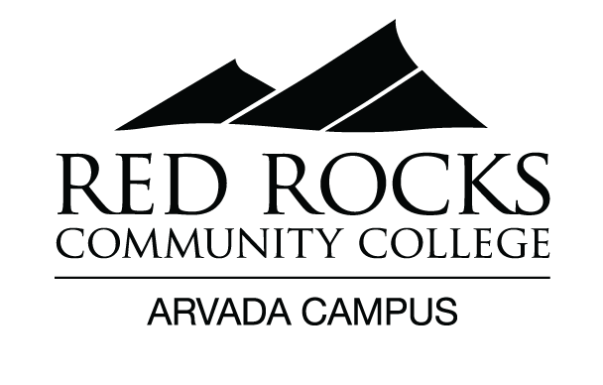
CAMPUS SERVICES & HOURS
SPRING 2020

WELCOME DESK  LEARNING COMMONS |  | Monday-Friday  8:00 am – 6:00 pm  Saturday  8:00 am – 5:00 pm  Open during Campus Hours |  |  |  | Student Health &  Counseling Center  Room 9420 | Mondays: 9:00 am-11:30 am Behavioral Health Services  Tuesdays: 9:00 am-12:00 pm Medical Services  Wednesdays: 9:00 am-4:00 pm Behavioral Health Services  Thursdays: No services available  Fridays: 9:00 am-4:00 pm Medical Services
ADVISING | Monday-Friday (appointments)  9:00 am – 5:30 pm  Tuesday MOT, MAP, HVAC program specific  9:00 am – 5:00 pm  Walk-in schedule  Monday & Friday 9:00 am – 4:30 pm |  |  |  |  | STUDENT LIFE |  | Monday – Friday  10:00 am – 3:00 pm  *hours subject to change
FINANCIAL AID | Monday – Friday  8:00 am – 5:00 pm |  |  |  |  | ASSESSMENT CENTER |  |  | Monday – Friday  9:00 am – 5:00 pm
Page 1 Spring 2020

CAFÉ |  |  | Mondays – Thursdays  8:00 am – 4:00 pm  Fridays  8:00 am – 1:00 pm  Saturdays  Closed |  |  | D2L &  Online Learning Support |  |  |  | Mondays & Thursdays  7:30 am – 4:00 pm  Tuesdays  8:00 am – 5:00 pm
BOOKSTORE |  |  |  |  | Hours May Vary  For updated hours please contact the  Arvada Bookstore 303.914.6022 | LIBRARY SERVICES |  |  |  | Tuesdays & Wednesdays  8:00 am – 3:00 pm  *And by appointment
IT/  COMPUTER SERVICES  Room 9310 |  |  |  | Monday-Friday  8:00 am – 5:00 pm |  | FITNESS CENTER  Questions or feedback regarding  the Fitness Center – email at src@rrcc.edu |  |  |  | Mondays – Fridays  11:00 am – 1:00 pm  &  3:00 pm – 6:00 pm
MARKETING  Room 7113 |  |  |  |  | Thursdays  *Hours may vary
Page 2 Spring 2020
*Some hours are subject to change. Please check back throughout the semester. (1.21.20)

