QUESTION 1

At this point, you should be able to articulate your ILEARN, Operational Unit, improvement plan. The questions below are three ways to ask the same thing.
In less than 50 words, please respond to the question that makes the most sense to you.
- What problem(s) have you identified in your Operational Unit that you will work to address?
- What is the focus of your Operational Unit improvement plan?
- What is your Operational Unit’s strategic plan for improvement?

ECE/EDU programs’ improvement plan is to reorganize under an Education Department to create ease of access to students for recruitment, retention, and completion in various educational pathways (ECE, Teacher Ed., Secondary/Post-secondary Instructor Professional Development)

The identified problems that motivates this project are
- being able to identify who our EDU students are when they apply for admissions to RRCC
- following through with program advising to achieve a higher completion rates as measured by certificates and degrees awarded
- improve VE-135 response rates above 50% (current response rate is 26.8% in 2015) for ECE program pathways.

Strategic plan:
- Update and implementing new degree maps -- in progress SP17
  - Working on MOU with CU-Denver for AA degrees (El. Ed and EC Ed) to create customized transfer agreement
  - Pursuing CTE program approval for AAS-ECE degree revisions
  - Implement new degree maps in fall 2017.
- Update EDU website and program brochures for recruitment – in progress SP17
- Request data sets for implementing student navigation/program specific advising plan
  - Current FTE disaggregated by course, and course format
  - Enrolled student contact info, and declared program of study
  - ABC completion rates for coursework
  - Graduation/program completion rates
- Create student navigation/advising plan.
- Build access database for student navigation/advising and/or utilize EAB software.
- Implement student navigation/program-specific advising plan.
- Provide faculty training on student key assessment rubrics.
- Implement on-going evaluation of student key assessment data and navigation/program specific advising data

QUESTION 2

What data supports the focus of the Operational Unit’s improvement plan?

- ILEARN June data sets
  - Access up-to-date FTE numbers,
  - ABC grade completion data,
  - graduation data for certificates and degrees,
  - institutional retention rates
- Student enrollment data (assessment scores, courses attempted/completed, personal contact info, declared program of study)
- VE-135 data
- Key assessment rubric data (from D2L)
- Program | 201730 – Spring 17 FTE | 201630 – Spring 16 FTE | Change | %Change

EDU - Education | 6.53 | 5.50 | 1.03 | 18.8%
ECE - Early Childhood Education | 28.53 | 29.67 | -1.13 | -3.8%

VE-135 data – ECE program

5 Year Completion Rate Trends
School | Red Rocks Community College |  | School Code/Suffix | 303
Program | EARLY CHILDHOOD EDUCATION |  | Level | Postsecondary
Program ID | 75155 |  | CIP ID | 131210
Program Request ID | 3890 |  | Non Trad | Yes, Female Dominated
Approval Date | 06/26/2015 |  | Expiration Date | 06/26/2020
Status | Active

5 Year Completion Rate Trends
Program at Red Rocks Community College |  |  |  |  |  | This CIP Statewide
School  Year | Status | Number Enrolled | Number of Completers | Completion Rate |  | Number Enrolled | Number of Completers | Completion Rate
14 | Active | 123 | 49 | 40% |  | 954 | 276 | 29%
13 | Active | 90 | 26 | 29% |  | 912 | 262 | 29%
12 | Active | 112 | 33 | 29% |  | 1075 | 251 | 23%
11 | Active | 126 | 30 | 24% |  | 1163 | 243 | 21%
10 | Active | 176 | 32 | 18% |  | 1314 | 306 | 23%
5 Yr Avg † |  | 125.4 | 34.0 | 27% |  | 1083.6 | 267.6 | 25%
Male |  | 3.8 | 0.6 | 16% |  | 39.8 | 6.6 | 17%
Female |  | 121.6 | 33.4 | 27% |  | 1043.8 | 261.0 | 25%
Ethnic Minority |  | 21.8 | 5.0 | 23% |  | 375.6 | 113.2 | 30%
Disadv |  | 35.6 | 11.4 | 32% |  | 413.0 | 108.8 | 26%
Disab |  | 2.6 | 1.2 | 46% |  | 22.4 | 10.4 | 46%
Limited English |  | 1.8 | 0.0 | 0% |  | 35.4 | 8.6 | 24%

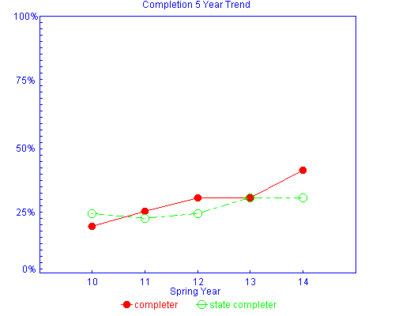

QUESTION 3

By fall 2019, how will you know if your Operational Unit’s improvement plan worked? In other words, what are your indicators of success?

Through the re-organization of ECE & EDU programs into an EDU department, we want to increase to following by 2019:

- Recruitment of students into designated EDU pathways (~5 FTE)
- Retain 50% of EC Entry certificate students into next certificate, and 30% of PS Teacher II students retained to AAS degree.
- 55% of enrolled students will receive program specific navigation/advising, as measured by 4 designated touchpoints and successful program graduation.
- 95-98% ABC grade completion of key course offerings [TBD] in each educational pathway.
  - Key assessments for SLOs in specific courses
  - ABC course completion
- Increased VE-135 responses (>50%) to measure completion rates in the ECE program pathway.

