CIP: English Developmental Education Redesign Fall 2012 – Spring 2014

QUESTION 1 (overview)

At this point, you should be able to articulate your ILEARN, Operational Unit, improvement plan. The questions below are three ways to ask the same thing.
In less than 50 words, please respond to the question that makes the most sense to you.
- What is the focus of your Operational Unit improvement plan?
- What problem(s) have you identified in your Operational Unit that you will work to address?
- What is your Operational Unit’s strategic plan for improvement?

The focus of the EGT program improvement is to increase enrollment, develop strategies to increase FTE in AEC and establish a recovery plan, and bring the curriculum up to date with industry standards.

The reason for the program improvement plan is to increase enrollment in on- campus courses. Also, due to the trend in decreasing FTE in AEC, the program is in danger of being phased out if enrollment does not increased. Finally, advisory board members suggested new program skills.

The strategic plan for improvement includes:
- Switching classes from day to night
- Eliminate one AEC course that overlapped information
- Increase individualized advising
- Align industry requirements to program offerings
- Redesigned AEC certificate requirements

QUESTION 2 (baseline data)
What data supports the focus of the Operational Unit’s improvement plan?

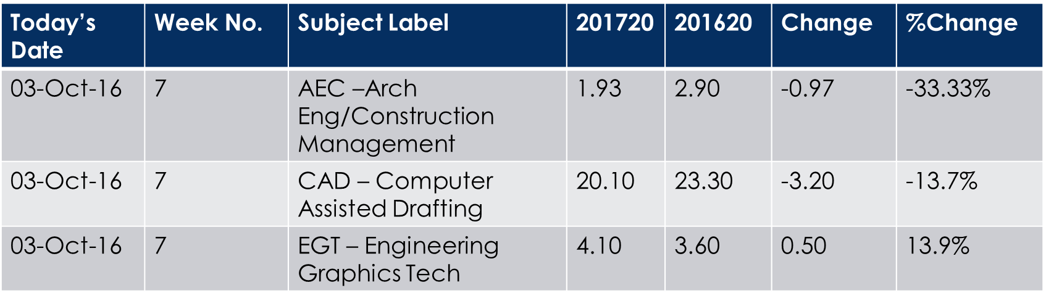
201720 FTE by Subject YTD Comparison
FTE comparison Oct2015 – oct2016

FTE Comparison
INSTERT Excerpts from advisory board minutes

QUESTION 3 (success indicators)
How will you know if your Operational Unit’s improvement plan worked? In other words, what are your indicators of success?

The EGT improvement plan will demonstrate success by
- Increasing program FTE by 10%
- Increase AEC 101 and 102 course enrollment by 30% each year for the next three years.
- Positive feedback from advisory board. Develop employer survey.

QUESTION 4 (comparative data)
What comparative data indicates success or areas of improvement?

QUESTION 5 (conclusions and future action)
What conclusion can be drawn from the results? What action will be taken based on the results?

