How to Print a Certificate of Eligibility (COE)

- Go to va.gov

- 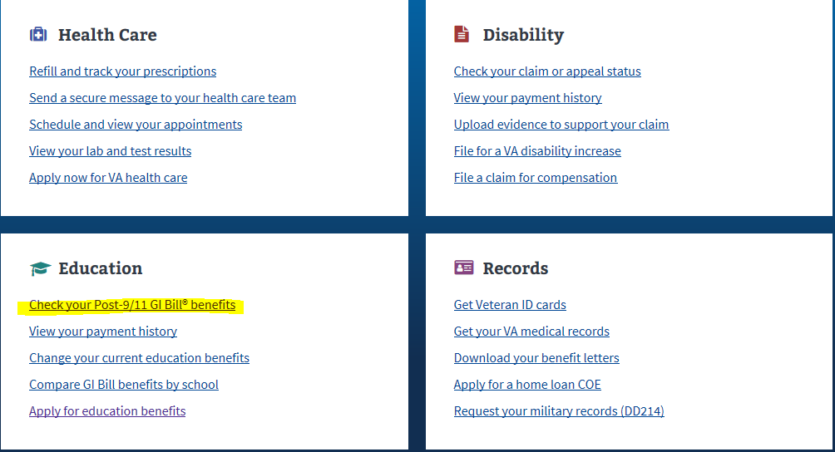

- Sign in/Create Account (DS logon/id.me)

- 

 