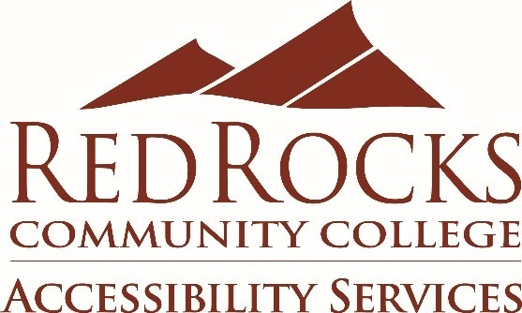
Event Accessibility Statement for Campus Sponsored Events
Statement:
Need accessibility? Contact Accessibility Services at 303-914-6733 or access@rrcc.edu at least one week prior to the event to request disability accommodations.
Rationale:
In order to ensure the accessibility of all campus sponsored activities, including on campus, remote and online events and meetings, an accessibility statement is requested on all event advertisements, announcements, emails, and flyers.
The statement informs event participants, including students, faculty, staff and guests, who to contact for accommodations such as wheelchair accessibility, American Sign Language interpretation, real-time transcription and captioning.
Accessibility Services will work with the sponsoring department to provide the requested accommodations. In all situations, a good faith effort will be made, up until the time of the event, to provide accommodations. Be aware that the sponsoring department may be responsible for costs incurred. Please use the statement below on the bottom of all event promotional materials.

