Red Rocks Community College

Fire Fighter I Academy Information

Spring 2020 Application Packet

This intensive 12 college credit hour program is 16 weeks in length (including state testing). The Academy provides an intensive instructional program that satisfies the certification requirement to take the State Firefighter I exams. The Academy’s rigorous instruction includes lectures by seasoned firefighters, and hands-on practical’s at West Metro Fire Rescue’s state of the art live burn facilities. The Academy student will experience operations such as house burns, car fires, forcible entry, ground fires, and many others. If you are looking for a career in firefighting, or if you want to serve as a volunteer firefighter in your community, this is an excellent place to begin.

Students who pass the Firefighter I portion may take the State (CDFP&C) Firefighter I written and practical certification exams, including the live burn exam (approximately $150).

Students who pass the Hazardous Materials portion may take the State (CDFP&C) Hazardous Materials Awareness and Operations written exams and practical certification exam (approximately $120).

State exams are not a requirement to pass the Academy, but is strongly recommended in order to participate with and be a part of most organizations post academy!

Please read the entire packet thoroughly for clear understanding of the application process and Academy expectations. All phases of the Academy are held at:

West Metro Fire Rescue Training Center
3535 S Kipling Street
Lakewood, CO 80235

Red Rocks Community College is committed to diversity in its people and programs. The College is an equal opportunity educational institution which prohibits all forms of discrimination and harassment including those that violate federal and state law, or the State Board for Community Colleges and Occupational Education Board Policies 3-120 and/or 4-120. The College does not discriminate on the basis of race, creed, color, sex/gender, sexual orientation, gender identity or expression, religion, age, national origin or ancestry, pregnancy status, veterans status, genetic information, physical and or mental disability or any other category protected by applicable law in its employment opportunities or education programs. The college will take appropriate steps to ensure that the lack of English language skills will not be a barrier to admission and/or participation in vocational educational programs. The college has designated Mr. Arnie Oudenhoven with the responsibility to coordinate its civil rights compliance activities and grievance procedures. For information contact: Mr. Oudenhoven at 303-914-6298
13300 West Sixth Avenue, Lakewood Colorado, 80228-1255

Mandatory Orientation:

- The mandatory orientation for the Spring 2020 Academy will be held on Jan 7th 2020 from 6:00 to 8:00 pm at the West Metro Fire Rescue Training Center, 3535 S. Kipling Street. After this date we will no longer register students for this semester’s academy except under certain circumstances approved by the Department Head or Dean of Instruction.
- The Fire Academy training is academically, physically and mentally rigorous and exacting; students are strongly encouraged to bring parents or spouses to this meeting so that they too may understand what will be asked of each Fire Academy student
- At the orientation, the Red Rocks Fire Academy Drill Master and the Faculty Lead or assignee will explain the guidelines, procedures, and policies required to successfully complete the Academy and pass the State written and practical exams

General Information:

- The Academy is held every Thursday and Friday from 6:50am to 5:00pm and runs January 16th to May 7th 2020. State testing dates are usually in the final week or just after the last class
- There is a maximum enrollment of 70 students
- Students should plan on spending approximately 2 hours of study/practice time for each hour spent in class and on practical skills (roughly 36 hours of homework/study per week)
- The State of Colorado Division of Fire Prevention & Control (CDFP&C) certification testing dates (Firefighter I and Hazardous Materials Operations) will be announced in the Academy
- RRCC Fire Academy Instructors teach to the National Fire Protection Standard 1001 (NFPA), and all instruction is mandated according to this standard

Schedule:

The fire academy consists of FST 100 and FST 107 which will meet at the West Metro Fire Rescue Training Center on Thursdays and Fridays. Your clinical rides will be scheduled outside of any class time.

Course | Title | Day(s) | Class Times | Course Dates
FST 100 - 551 | Essentials of Firefighting | RF | 6:50 am – 5:00 pm | 01/16/2020 to May 7th 2020
FST 107 - 551 | Hazardous Materials Operations | RF | 6:50 am – 5:00 pm | 01/16/2020 to May 7th 2020
FST 170 - 001 | Clinical rides scheduled outside of class time

Prerequisites:

- Proof of age 18 by the first day of class (no exceptions)
- Must possess a high school diploma or GED
- The student must be eligible to enroll in ENG 121 or provide proof of completion of ENG 121, or its equivalent, with a grade of C or higher

Co-requisites:
The fire academy is generally taken during the first semester of the Fire and Emergency Services Degree, or the second semester of the Fire Science Technology Degree. It is recommended that you take at least one three credit general education course during this semester to stay on track to complete either degree in four semesters

Program Cost:

Resident tuition and fees (with COF applied) are approximately $2,500. Nonresident tuition and fees are approximate. Included in these figures is a special Fire Science fee of $425. Financial aid or grants may be available. Please contact RRCC Financial aid directly with questions.

Each addition each student must purchase required textbooks and workbooks (approximately $300), NFPA compliant structural firefighting “bunker” boots (approximately $150), NFPA compliant structural firefighting gloves (approximately $80), Protective hood (approximately $40), two academy tee shirts (approximately $15 each) and two Blue BDU style pants (approximately $35 each). Vendor information will be provided at the orientation.

All tuition and costs listed are approximate and subject to change.

Physical Demands:

Firefighting is an extremely physically demanding profession. Students are expected to be physically fit. To participate in the academy, students are required to pass the West Metro Fire Rescue Physical Ability Test (WMFR PAT). The test is administered at the start of the academy. Information about the PAT is available at:

- WMFR Physical Ability Test (PAT)

- WMFR Detailed Physical Ability Test

- WMFR PAT Video

- WMFR PAT Suggested Work-Out Programs

Students should not underestimate the physical demands of the academy. It is crucial that students have an exercise program prior to attending the academy, and start increasing their endurance and aerobic conditioning several months prior to the start of the academy

Students are required to provide a signed Medical Release Form on the first day of the Academy. Students will not be allowed to participate without this form. RRCC students can have this form completed at the Red Rocks Student Health Clinic.

Academic Demands:

The program demands a high level of academic performance both within the classroom as well as with homework assignments. This requires the student attend all class sessions as well as adequately prepare for and follow through with the workload outside of class. Students can expect approximately two hours of homework/study time for each hour of time spent in class or on Drill Ground. This equates to an additional 36 hours per week outside of the classroom or Drill Grounds.

RRCC discourages students from participating in the academy if this is their first semester of post-secondary education. This is due to the heavy workload and self-discipline necessary to successfully complete the academy. Students will need a high level of maturity to meet the challenge.

College Placement Exam:

The college placement exam is offered at the RRCC Assessment Center for students who have not met the English 121 pre-requisite. Please visit the Assessment Center website for testing times and availability, or contact them at 303-914-6720.

No appointment is needed for the computerized exam and there is no cost for the initial attempt. Allow approximately two hours to complete the exam. Placement exams must have been taken within the last five years to be accepted for admission into the academy

Registration Process:

Registration for the Spring 2020 semester will start on November 4th 2019. Students with all of the required pre-requisites are admitted to the program on a first-come, first-served basis. Please complete the steps shown below to register for the course:

- Complete the RRCC online application and sign up for COF (College Opportunity Fund) at Red Rocks Community College.
- Ensure eligibility to enroll in ENG 121 either through placement exam scores or prior coursework, or show proof of prior completion of ENG 121, or its equivalent, with a C or better.
- Obtain a copy of your high school diploma or GED.
- Complete a background check (Instructions come later in this document)
- Obtain proof of age 18 by the first day of class (no exceptions).
- Once the above documents/processes have been completed, meet with a RRCC advisor. Advisors register students for the Fire Academy and will check for completion of this application.
- Complete FEMA online classes to obtain the ICS certificates.

First Day of Class:

- Bring the following information to the first day of class
- Copy of Driver’s License or a government issued photo ID with birthdate
- Copy of FEMA ICS 100, ICS 200, and ICS 700 certificates
- Proof of completion of a background check through CastleBranch
- Proof of healthcare insurance
- Completed student information form
- A completed medical release form, signed by a health care provider, documenting that you do not have any condition that would endanger your health during your education
- Proof of vaccinations and a TB test within 12 months are also required.
- The medical release form and vaccinations can be completed by the student’s primary care physician, or at the Red Rocks student health clinic
- A completed RRCC Release of Liability Form
- A completed WMFR Release of Liability Form
- A CPR card demonstrating completion of a CPR course at either the Healthcare Provider or BLS Provider level. This is a one day course offered at Red Rocks Community College as HPR 102. It may also be taken at any CPR training center. The card must be valid through 5/31/2019
- Required textbooks obtained from the RRCC bookstore

Background Check

The background check is completed by an external company, CastleBranch, and is mandatory for all students participating in a healthcare program. Background checks must have been completed within the last 12 months, and cannot be transferred from another school.

Please visit the CastleBranch website (cccs.castlebranch.com) to complete the background check.

- On the home screen please click on “Place Order”
- Click on “Red Rocks Community College” on the page requesting you to select your school
- From the dropdown box choose “Fire Science Technology Academy”
- From the next dropdown box that appears on that page choose the appropriate option
- Do not click anything, just wait for the page to reload
- Confirm your order, click the box at the bottom indicating you have read the terms and conditions, and click on “Continue Order”
- Complete the following screens providing the requested information.
Be sure your information is correct. It is not possible to make changes to your order after it has been submitted. IF your order is submitted with incorrect information you will need to submit another background check with additional fees.

Please contact CastleBranch at 1-888-723-4263 or customerexp.cu@castlebranch.com with any questions or if you experience any problems with the ordering process.
If the investigation reveals information that could be relevant to the application, the designated individual responsible for background checks may request additional information from the applicant. The offense shall be reviewed on a case by case basis.

Students who have successfully completed the terms of a deferred adjudication agreement will not be disqualified.

If any applicant feels the criminal background check is inaccurate, they may appeal the decision and request a review with the specific community college applied at. It is the applicant’s burden to produce substantial evidence that proves the crimes charged are incorrect.

Disqualifying offenses:

Any conviction of the following criminal offenses appearing on a criminal background check will disqualify an applicant for admission to a CCCS Health Program.

- Any violent felony convictions of homicide
- Crimes of violence (assault, sexual offense, arson, kidnapping, any crime against an at-risk adult or juvenile, etc.) as defined in section 18-1.3-406 C.R.S. in the 7 years immediately preceding the submittal of application
- Any offense involving unlawful sexual behavior in the 7 years immediately preceding the submittal of application
- Any offense of which the underlying basis has been found by the court on the record to include an act of domestic violence, as defined in section 18-6-800.3 C.R.S. in the 7 years immediately preceding the submittal of application
- Any crime of child abuse, as defined in section 18-6-401 C.R.S. in the 7 years immediately preceding the submittal of application
- Any crime related to the sale, possession, distribution or transfer of narcotics or controlled substances in the 7 years immediately preceding the submittal of application
- Any felony crimes of theft in the 7 years immediately preceding the submittal of application
- Any misdemeanor crimes of theft in the 5 years immediately preceding the submittal of application
- Any offense of sexual assault on a client by a psychotherapist, as defined in section 18-3-405.5 C.R.S. in the 7 years immediately preceding the submittal of application
- Crimes of moral turpitude (prostitution, public lewdness/exposure, etc.) in the 7 years immediately preceding the submittal of application
- Registered sex offenders (No time limit)
- More than one (1) D.U.I. in the 7 years immediately preceding the submittal of application
- Any offense in another state, the elements which are substantially similar to the elements of any of the above offenses

Approved CCCS 6/8/2007. Re-approved 4/12/2012. Reviewed and amended 4/1/2019

Acceptable BCLS Cards

As stated in Colorado Board of Health Rules 6-CCR-1015-3, Chapter 1- EMS Rules CPR at the healthcare provider level is required to be an EMT in the state of Colorado. Moreover most of the EMS agencies and hospitals we utilize for the clinical and internship portions of our programs require CPR for the Healthcare Provider or BLS provider from the American Heart Association. Therefore the following CPR cards are the only ones that will be accepted by the RRCC EMS Program.

American Heart Association

- Healthcare Provider
- BLS Provider
- BLS Instructor
- BLS Training Center Faculty

The BLS Provider course is a one day course offered at Red Rocks Community College as HPR 102

The exact card issued may look like one of the examples on this page or may vary based on when it was issued.

The decisions of the RRCC clinical coordinator regarding whether or not a course meets the RRCC clinical requirements is final

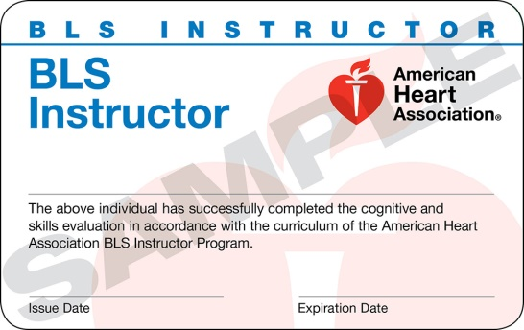
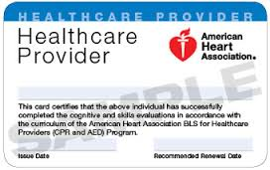
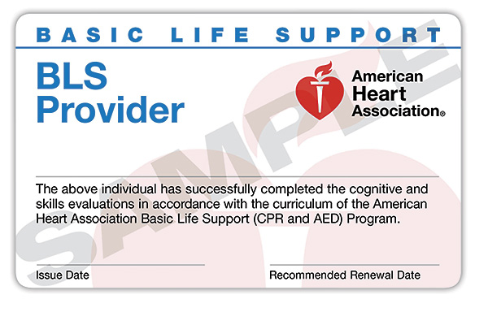
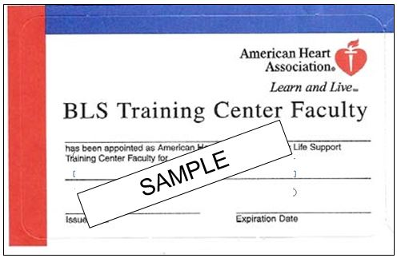

Firefighter I Academy Student Information Form

Please type or print

Student ID number: (S number issued by RRCC):________________________________

Name: ___________________________________________________________________
Last First Middle

Date of Birth: (Month, Day, Year) _________________ Male: _____ Female: _____

Mailing Address: __________________________________________________________

City, State, Zip: ___________________________________________________________

Preferred Phone: ___________________ Secondary Phone:________________________

Email Address:____________________________________________________________

Emergency Contacts

Name Relationship Primary Phone Secondary Phone
________________________________________________________________________
________________________________________________________________________
________________________________________________________________________

Current medications: _______________________________________________________

Allergies: _________________________________________________________________

Personal Physician: ________________________ Phone: __________________________

In the event of an emergency, I hereby authorize Red Rocks Community College and/or West Metro Fire to release all information on this form to appropriate medical personnel.

Printed Name: _____________________________________________________________

Signature: _____________________________________________ Date: ______________

Red Rocks Firefighter 1 Academy Medical Release Form

Please Type or Print

Instructions for Providers

The above-named person has been extended an offer of admission to the Red Rocks Community College Fire Academy. To matriculate into the Academy, the student must demonstrate that he/she is free of any medical conditions that would prevent him/her from performing the physical tasks necessary for a fire career.
Academy students are expected to perform at emergency incidents and will be required to perform in training drills and emergency exercises. Students will participate in exercises that include but are not limited to fire suppression activities, ladder exercises, hose and fire stream operations, and physical conditioning. Tasks that the academy students will be asked to do (but are not limited to) will include: running, sitting, lifting, throwing, kneeling, squatting; general calisthenics - sit ups, pull ups, pushing, jumping, and obstacle courses, etc.

These students are required to meet the standards of CFR 1910.134 (Respiratory Protection). At the expense of the student, please interview and examine this prospective student and complete the statement on the following page.

Medical conditions that may disqualify a person from participating in the academy include but are not limited to:

- All uncontrolled seizure disorders
- Allergic respiratory disorder
- Anemia
- Arthritis
- Asthma
- Chronic lung diseases
- Chronic sinusitis
- Congestive heart failure
- Diabetes mellitus
- Disorders producing orthostatic hypotension
- Documented predisposition to heat stress
- Emphysema
- Hemophilia, VonWillebrand's disease and other clotting/bleeding disorders
- Hernia
- Impaired immune system
- Labyrinthine or vestibular disorders with vertigo
- Malignant diseases not in remission
- Multiple sclerosis
- Muscular atrophies
- Myocardial insufficiency
- Neurological disorders with ataxia
- Peripheral vascular disease
- Pregnancy (after 1st trimester)
- Progressive muscular dystrophy
- Severe congenital deformities of the spine, trunk, or limbs
- Severe eczema or other dermatitis including dyshidrotic types
- Severe limitations of motion of joints

Additional Reference: NFPA 1582 – Medical requirements for fire fighter

This form is valid for 12 calendar months.

You are welcome to call the Red Rocks Fire Academy Coordinator at 303-914-6791. Please complete and sign the back of this sheet. Thank you!

Red Rocks Firefighter 1 Academy Medical Release Form
Name of patient:_______________________________________________________

I understand the above-named patient has been tentatively extended an offer of admission to the Red Rocks Firefighter 1 Academy during the _______________ semester of 20_____

I have examined ________________________ and have determined that in accordance with CFR 1910.134 (Respiratory Protection) the applicant

___ Does not have a health or physical condition which could endanger the health or well-being of themselves, faculty or students, or would prevent them from performing the physical tasks required for a firefighter academy

___ Does appear to have a health or physical condition which could endanger the health or well-being of themselves, faculty or students, or would prevent them from performing the physical tasks required for a firefighter academy

Additional Requirements:

Please also provide documentation of the following tests/vaccinations:

- Chicken pox or Varivax vaccination Date of illness or vaccination: ________________
- Tetanus Date of last vaccination or booster: _____________
- MMR Date of last vaccination or booster: ________________
- Tuberculosis Testing ( less than one year old)

Date Tested: _____________ Date Read: ____________ Positive/Negative (circle one)

If positive, date re-tested: ________ Date Read: ________ Positive/Negative (circle one)

If positive, date of Chest X-Ray: _________________________________________________

If positive, start date/end date of treatment: ______________________________________

- Hepatitis B Vaccine (3-shot series)

Date 1st vaccine received ______________ Titer Date (if applicable): _______________
Date 2nd vaccine received ______________ Results: _____________________________
Date 3rd vaccine received ______________

- Seasonal Influenza Vaccine Date of vaccination: _________________

__________________________________________
Signature of provider

__________________________________________
Printed name and Professional Degree of provider
_______________________
Date

_______________________
Telephone number

RED ROCKS COMMUNITY COLLEGE

STUDENT WAIVER OF LIABILITY FORM

Red Rocks Community College is an Institution of Higher Education in the State of Colorado and, as such, is covered by the Colorado Governmental Immunity Act, C.R.S. 24-20-101 et seq. This law provides that the State and its institutions are immune from lawsuits for injuries suffered by private persons, except, in specific situations listed in the law, where immunity is specifically waived. In other words, by law, if a student suffers an injury as a result of a participation in instructional activities of the college, the college is immune from fiscal liability for such injury. For this reason, students are strongly encouraged to obtain medical insurance coverage, if they do not already have coverage, before participating in activities that present a risk of physical injury.

I am exercising my own free choice to participate voluntarily in (Firefighter One Training Academy), and I promise to take due care during such participation. I have been informed of the nature of these activities, and I am aware of the hazards and risks that may be associated with my participation in these activities, including the risks of bodily injury, death or damage to property from known or unknown causes.

In consideration of the privilege of participating in instruction offered by employees of Red Rocks Community College, I have and do hereby assume all risks and will hold Red Rocks Community College and its employees and agents harmless from any and all liability, actions, causes of action, debts, claims and demands of every kind and nature whatsoever which I now have or which may arise from or in connection with participation in instruction activities arranged for me by Red Rocks Community College or its employees or agents. The terms hereof shall serve as a release and assumption of risk for my heirs, executors and administrators and all members of my family.

In signing below I hereby assert that:

- I have read this document
- I understand that Red Rocks Community College is covered by the Colorado Governmental Immunity Act
- I am personally liable for injuries that I may suffer as a result of participation in this activity

Student Signature ________________________________________ Date ________________

Witness ________________________________________________ Date ________________

WEST METRO FIRE RESCUE

RELEASE AGREEMENT

By participating in any training program (regardless of the sponsorship of such program), that involves the use of any of the facilities of the West Metro Training Center (herein, “Facilities”), the undersigned participant expressly agrees the West Metro Fire Protection District shall not be liable for any damages arising from personal injuries sustained by the party in, on or about the premises of the Facilities or as a result of using the Facilities and/or the equipment thereon.

By the execution of this Agreement, the undersigned participant acknowledges and assumes full risk and responsibility for any personal injuries, damages, or losses which may occur to such participant on or about the premises of the Facilities, regardless of participation in any program, and does hereby fully release and discharge the West Metro Fire Protection District (including its officers, employees and agents) from any and all claims, demands, rights of action or causes of action, present or future, known or unknown, resulting from arising out of the undersigned’s use of the Facilities or the equipment thereon.

The undersigned further acknowledges and agrees that the West Metro Fire Protection District (including is officers, employees, and agents) shall not be liable for any damage, loss or theft of any party’s personal property occurring while the undersigned is present at the Facilities.

The undersigned also acknowledges and agrees that the West Metro Fire Protection District, acting by and through its Training Center employees, reserves the right to call emergency medical aid for an injured party and said party accepts responsibility for any financial obligations arising from such emergency medical aid or transportation to a medical facility, through health insurance or otherwise.

Party agrees to keep and obey all rules and regulations of the West Metro Training Center for the use of facilities and the equipment and facilities therein.

This Agreement shall be interpreted in accordance with the statutes of the state of Colorado, and if any particular provision in this contract shall be deemed invalid, the same shall not affect the balance of this contract and the remaining provisions thereof.

This release and agreement shall be binding upon me, any of my heirs, executors, administrators, personal representatives and assigns, and shall inure to the benefit of the said Fire Protection District, officers, and members herein designated, and their heirs, executors, administrators, personal representatives, assigns and successors in office.

Dated this: day of ___________________, 20_________

Printed Name: ______________________________________________________________

Address: ___________________________________________________________________

City, State, Zip: ______________________________________________________________

Signature: _________________________________________________________________

Instructions for completing FEMA online courses

Prior to the first day of the academy you will need to go to the FEMA website for the on-line Independent Study Program (ISP) classes. These are available at NO COST. You will need to complete the following courses and bring the certificates with you to class on the first day. Each certificate is worth 3 points towards your grade. It can take up to a week to get your certificates, so do this as soon as possible.

- ICS-100 – Introduction to the Incident Command System
- ICS-200 – ICS for Single Resources and Initial Action Incidents
- ICS-700 – National Incident Management System, An Introduction

Scroll down to select a course and complete it. After you take the final test at the end of each course you will enter your information into their system and they send you an email letting you know if you passed or not. If you passed, there will be a link to a site to print out a certificate for that course. If you did not pass, you will have instructions on how to retake the test.

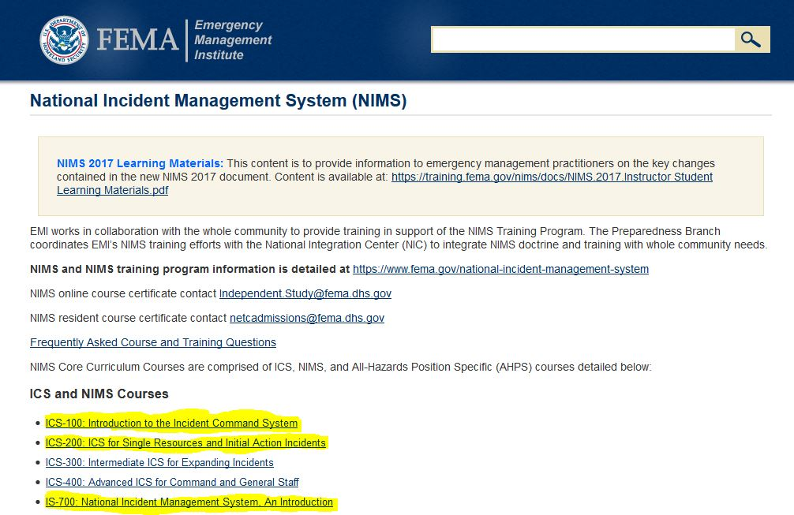

OSHA Medical Reporting

To be completed by the applicant

Name: ____________________________________________Date: _____________________

Phone: ______________________________________________________________________

Date of Birth: __________________________________Sex: ____________________________

Height: ________________________________ Weight: ____________________________

- Have you worn a respirator? Yes ________ No ________
  - If yes, what type? ____________________________________________________
- Do you currently smoke tobacco? Yes ________ No _________
- Have you smoked tobacco in the last month? Yes ________ No _________
- Have you ever had any of the following? (Circle or highlight all that apply)

  - Seizures
  - Diabetes
  - Allergic reactions
  - Claustrophobia
  - Pulmonary problems
  - Lung problems
  - Asbestosis
  - Asthma
  - Emphysema
  - Pneumonia
  - Tuberculosis
  - Silicosis
  - Pneumothorax
  - Lung cancer
  - Broken ribs
  - Chest injuries
  - Chest surgeries
  - Other lung problems
  - Current lung problems
  - Shortness of breath when:
    - Walking fast uphill
    - Walking fast on level ground
    - Washing or dressing
    - Working – Interferes with job
  - Coughing that produces phlegm
  - Coughing that wakes you in the morning
  - Coughing up blood
  - Wheezing
  - Wheezing that interferes with job
  - Chest pain when you breathe deeply
  - Cardiovascular or heart problems
  - Swelling in hands or feet
  - Stroke
  - Angina
  - Heart failure
  - Heart arrhythmia
  - High blood pressure
  - Other heart problems
  - Frequent pain or tightness in your chest
  - Pain or tightness in your chest during physical activity
  - Pain or tightness in your chest that interferes with your job
  - Heart skipping or missing a beat
  - Heartburn or indigestion not related to eating

- Do you currently take medications for any of the following? (Circle or highlight all that apply)

  - Breathing or lung problems
  - Heart problems
  - Blood pressure
  - Seizures

- If you have used a respirator have you had any of the following? (Circle or highlight all that apply)

  - Eye irritation
  - Skin allergies or rashes
  - Anxiety
  - General weakness or fatigue
  - Other problems (Specify:_________________________)

- Have you ever lost vision in either eye? Yes ________ No _________
- Do you currently have vision problems? Yes ________ No _________
- Do you wear any of the following? (Circle or highlight all that apply)

  - Glasses
  - Contact lenses

- Are you color blind? Yes ________ No _________
- Have you ever had any injury to your ears? Yes ________ No _________
- Do you currently: (Circle or highlight all that apply)

  - Have difficulty hearing
  - Wear a hearing aid
  - Have any other ear trouble

- Have you ever had a back injury? Yes ________ No _________
- Do you currently have any of the following? (Circle or highlight all that apply)

  - Weakness in any of your arms, hands, legs, or feet
  - Back pain
  - Difficulty fully moving your arms or legs
  - Pain or stiffness when you lean forward or backward at the waist
  - Fully moving your head up and down
  - Fully moving your head from side to side
  - Bending at your knees
  - Squatting to the ground
  - Climbing a flight of stairs or ladder with more than 25 pounds
  - Other musculoskeletal problems

- Do you have dizziness, shortness of breath, pounding in your chest, or other symptoms at high altitudes? Yes ________ No _________
- Have you ever been exposed to hazardous solvents or hazardous chemicals? Yes ____ No _____
  - If yes specify:__________________________________________________________________
_____________________________________________________________________________
- Have you ever worked with any of the following? (Circle or highlight all that apply)

  - Asbestos
  - Silica
  - Tungsten
  - Cobalt
  - Beryllium
  - Aluminum
  - Coal dust
  - Iron
  - Tin
  - Dusty conditions
  - Other hazardous exposure

- List any secondary jobs or businesses: ________________________________________________
________________________________________________________________________________
________________________________________________________________________________
- List your previous occupations: ______________________________________________________
________________________________________________________________________________
________________________________________________________________________________
- List your current and previous hobbies: ________________________________________________
_________________________________________________________________________________
_________________________________________________________________________________
- Have you ever been in the military? Yes ________ No _________
- Have you ever worked on a HAZMAT team? Yes ________ No _________

